Eclipse Test & Performance Tools Platform Project

Test & Performance Tools Platform (TPTP) Project - TPTP provides powerful frameworks and services for an open platform upon which developers build unique test and performance tools—both open source and commercial—that easily integrate with Eclipse and other tools and address the entire test and performance lifecycle, from developer testing through production monitoring. More info can be found in eclipse site for this project

Log and Trace Analyzer

Log and Trace Analyzer component in TPTP enables viewing, analysis, and correlation of log files, as well as, authoring of symptom catalogs, and authoring and testing of log parser adapters

Setup Instructions

Eclipse TPTP and the LTA can be installed by downloading the individual plug-ins required for these set of tools or downloading the following 3 packages,

- Download Eclipse TPTP all-in-one package from this site http://www.eclipse.org/tptp/home/downloads/?ver=4.5.0
- Download "All TPTP plugins" in the same page as above (some of these plug-ins are required for Profiling which I will cover later)
- Download Log And Trace Analyzer from this site http://www.eclipse.org/tptp/home/downloads/?ver=4.5.0

Downloading the Runtime is sufficient for Log Analysis and correlation. After downloading the above unzip them into the same folder.

Log Viewer

Log Viewer component lets you look at the events from the log file.

Switch to Profiling and Logging perspective

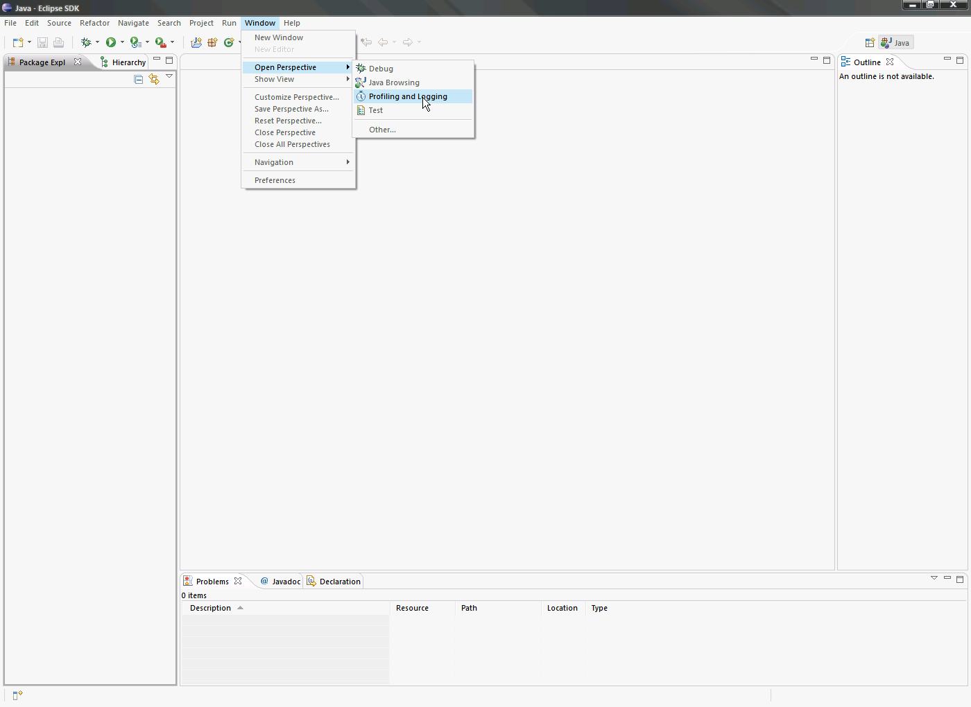

Log files created in XML format.
GigaSpaces by default does not use XML format for logs. Change this to XML by commenting the following line in gs_logging.properties file which will make logger to switch to default formatter,

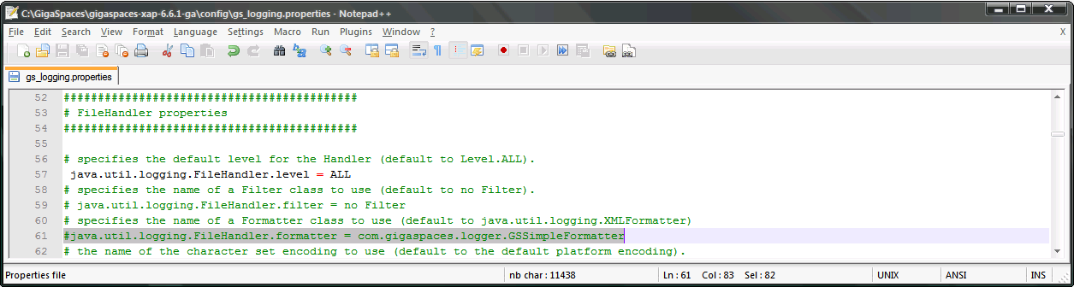

Start the Import log file wizard using following menu option File > Import > Log file

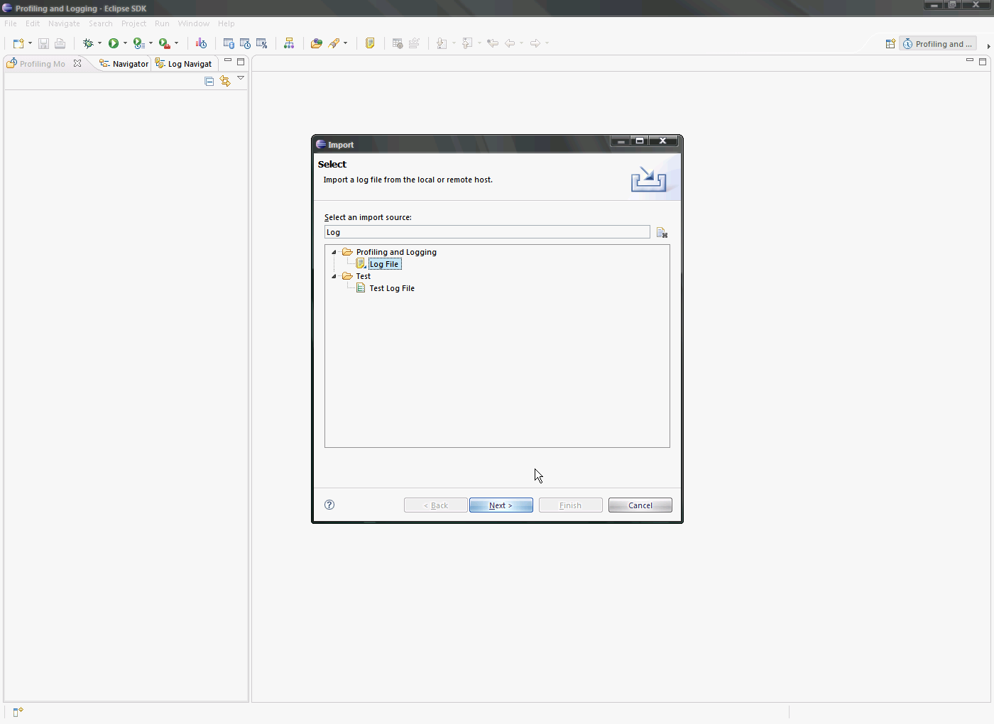

Create “New Log Set” and give it an appropriate name “Log And Trace Analyzer Demo”

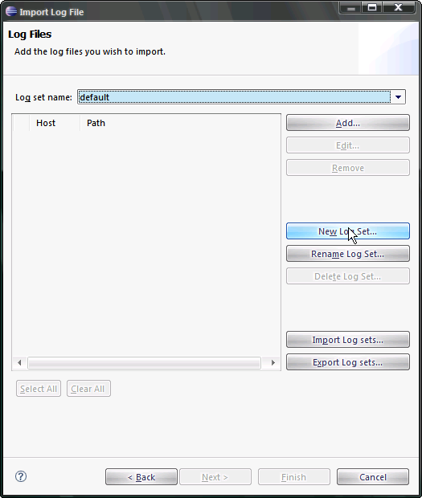

Click the “Add” button to add log files

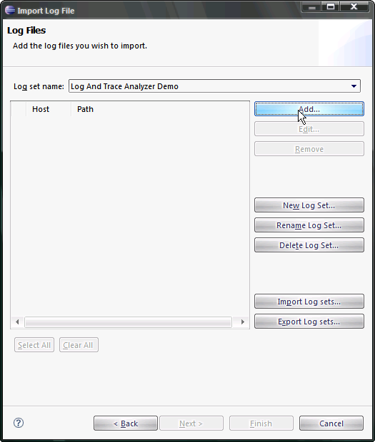

Choose “Java Logging XML Log” option and hit the Browse button

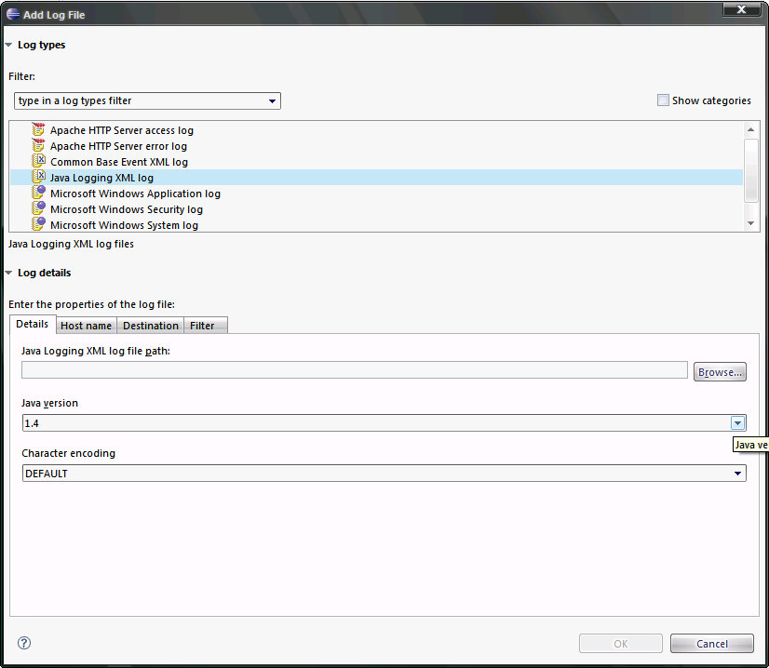

Navigate to the folder with log files and select appropriate files

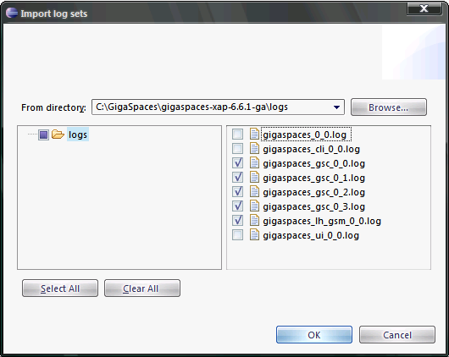

Change the Java version and hit “OK” followed by the Finish button in the next screen. Give Eclipse some time to process the files

Information from log files is dissected and presented as shown below,

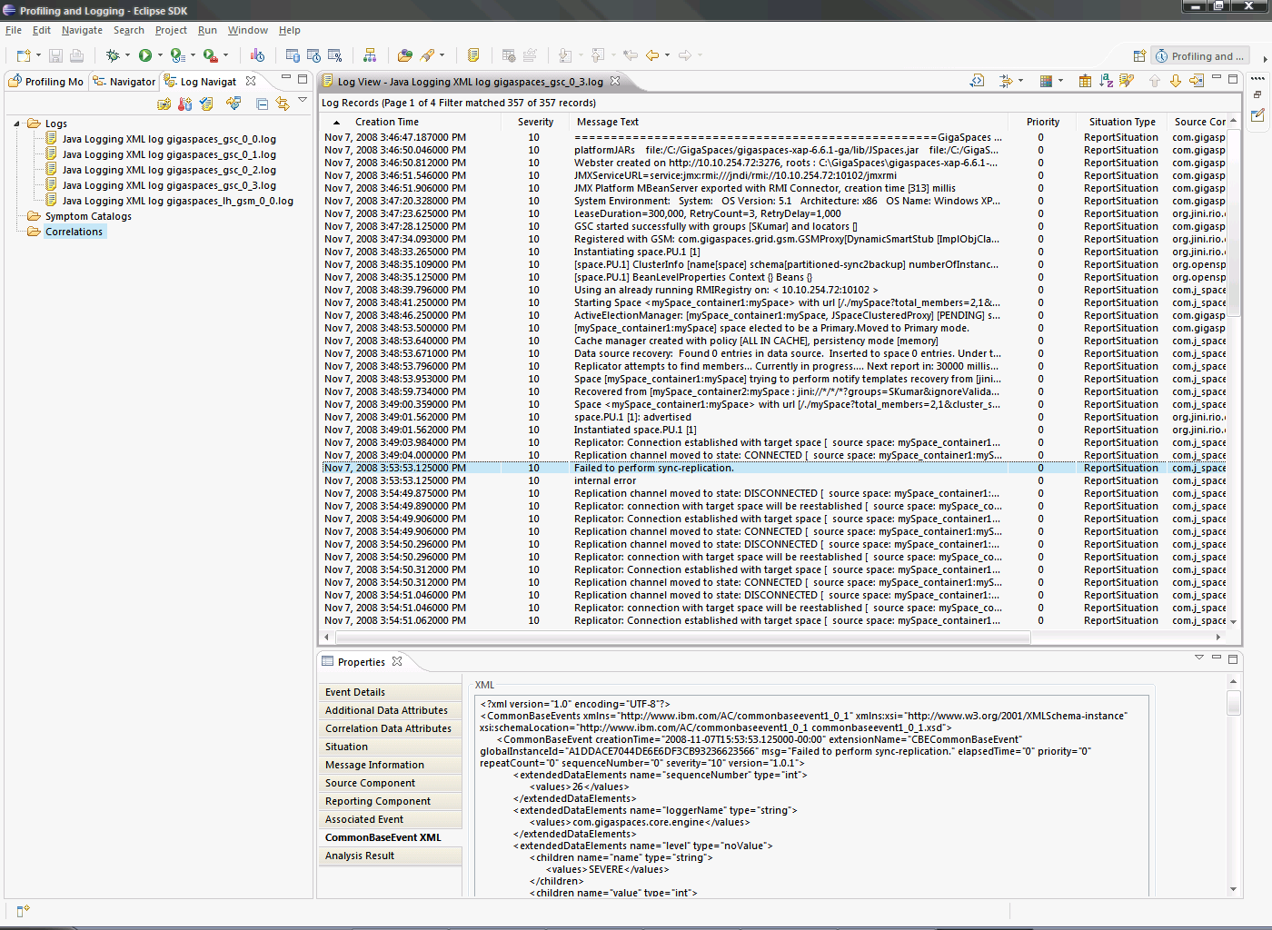

Log Correlation
To correlate events from different log files and visualize it you have to create a Log Correlation which is where the LTA shines

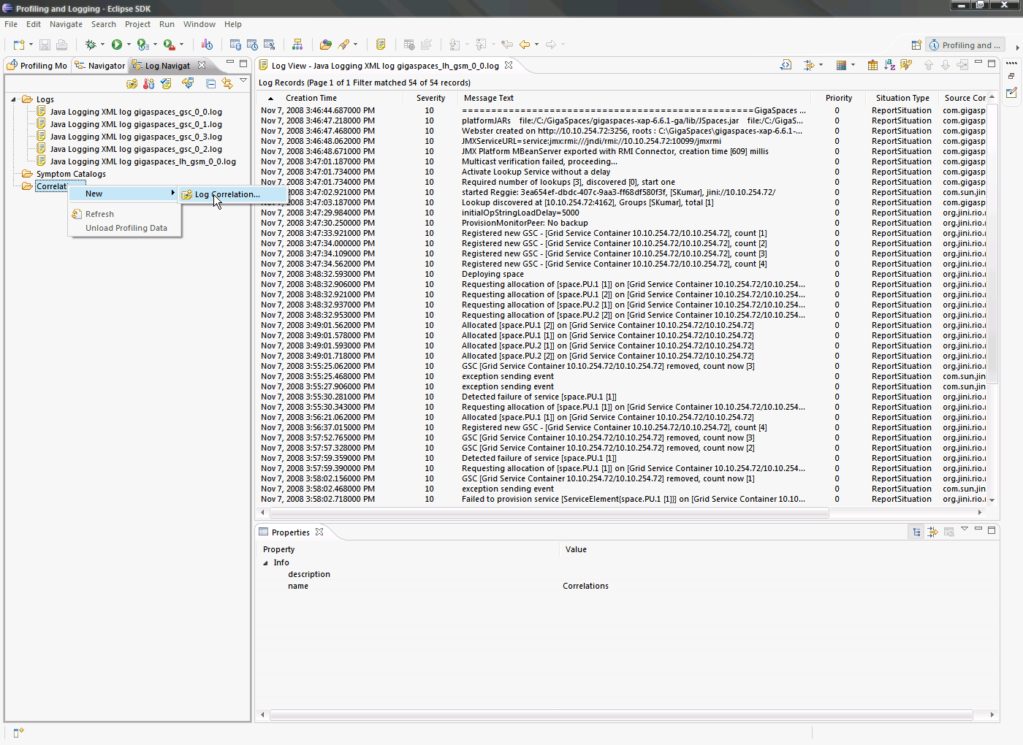

Select all the log files you would like to correlate and hit Finish

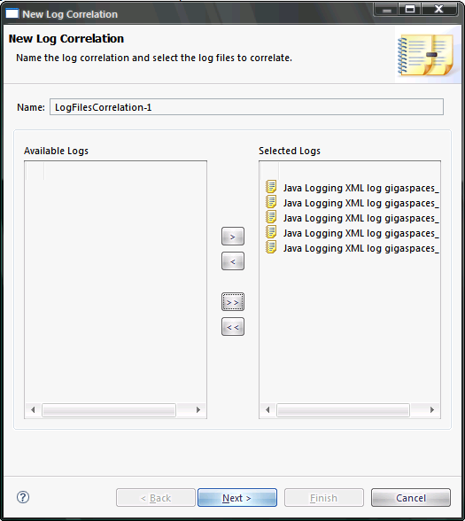

Double clicking the new correlation just created and shows the events in each log file as a UML2 Interaction diagram

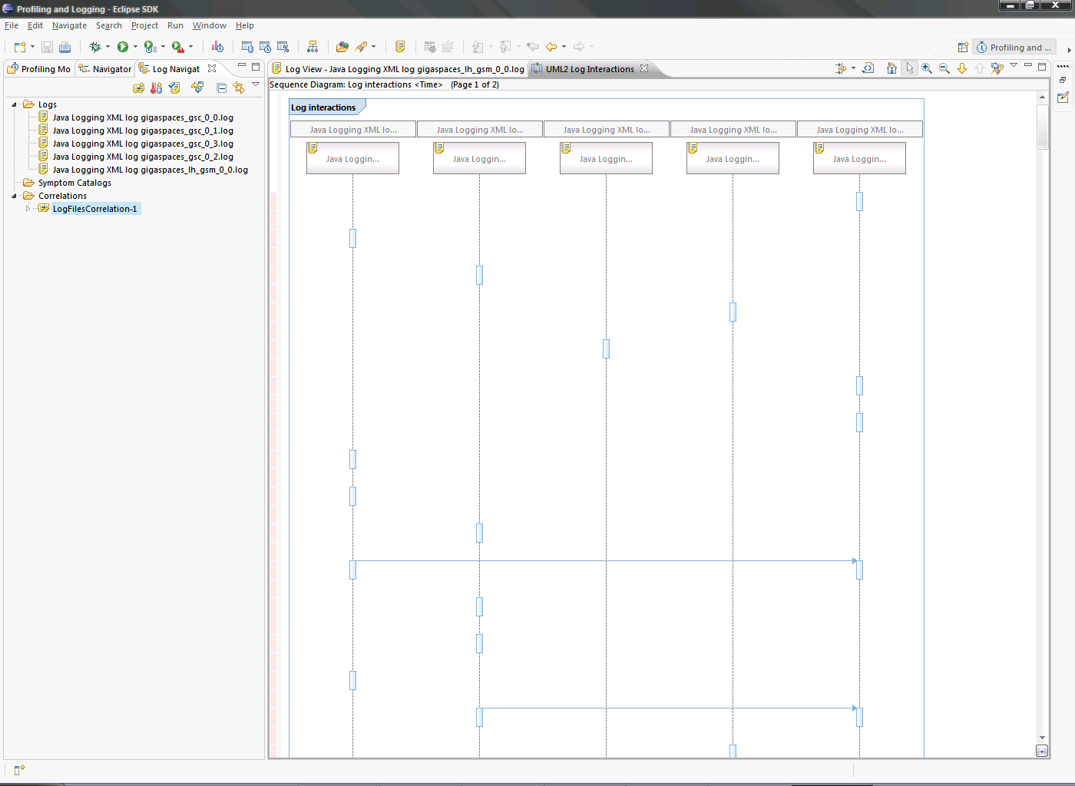

For e.g. using the event correlation I can see that there is a replication issue between two cluster members

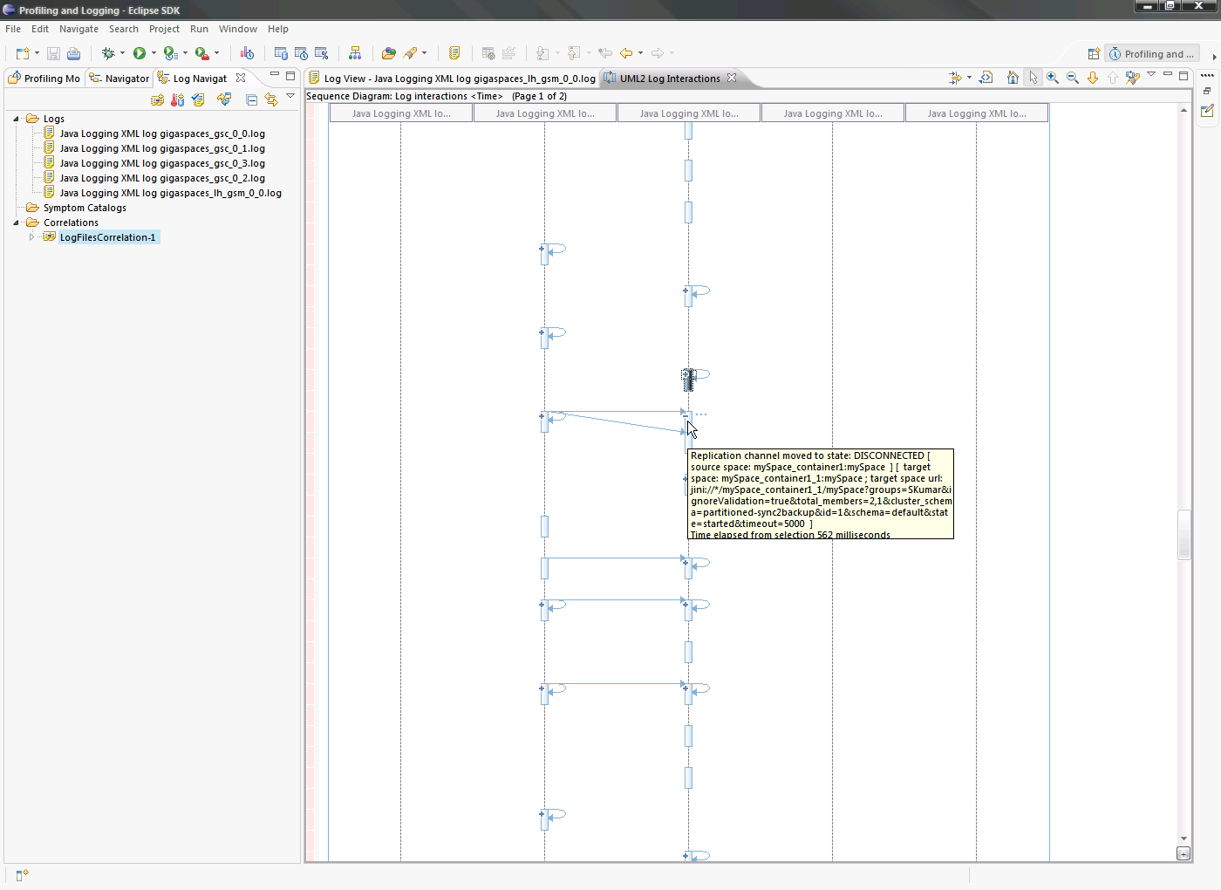

Limitations
LTA is a good starting point for troubleshooting GigaSpaces application issues. This tool out of the box can only work with certain type of files. For example it can analyze Java Util logging files created only in XML format or Common Base Event XML log files. Fortunately LTA/GLA (Generic Log Adapter) framework provides extension points to overcome this limitation.

I will send more information about how to correlate non-XML log files very soon

References

- TPTP Installation guide http://www.eclipse.org/tptp/home/downloads/4.5.0/documents/installguide/InstallGuide45.html

- Eclipse Help site with more information about this tool is here,
http://help.eclipse.org/help32/index.jsp?topic=/org.eclipse.tptp.platform.doc.user/tasks/teanlog.htm

- “Symptomatic event visualizer” series, explains the challenges of working in a multi-machine software and how to use LTA and other IBM tools in this environment http://www.ibm.com/developerworks/autonomic/library/ac-ltavisual1/index.html

